**Known Behaviours**

|  |  |
| --- | --- |
| If the 'USB to RS485' converter is connected to the CIPer Model 30 controller's USB port while running station, then no COM port will be detected by the station. | To detect the COM port, power-cycle the CIPer Model 30 controller. |
| If the 'USB to RS485' converter is disconnected from the CIPer Model 30 controller’s port while the station is running then the serial communication will stop working. | To resume the serial communication.   1. Plug-in 'USB to RS485 converter or check the connections. 2. Power-cycle the CIPer Model 30 controller. |
| If the connected  'USB to RS485' converter FTDI Cable is replaced with a new 'USB to RS485' converter (e.g. from a different Vendor) Then the name of the com port might change.  If the station is running while this change is done, the serial communication will stop working.    This will break the COM port mapping and the Serial Communication will fail to start. | To resume the serial communication.   1. Verify the new COM port name 2. Resume the serial communication power-cycle the CIPer model 30 controllers. |

**USB Support**

The CIPer Model 30 controller has a single Type-A USB socket that supports RS-485 communication via RS-485 converter. The RS-485 communication is limited to three RS-485 devices.

The RS-485 allows multiple devices to communicate at half-duplex on a single pair of wires, plus a ground wire, with distances up to 1200 meters (4000 feet) and supports MODBUS and BACnet MSTP protocols. The support-ed chipset used in USB to RS485 converter are FTDI (FT232 series) and prolific chipset (PL2303).

[www.waveshare.com/usb-to-rs485.htm](http://www.waveshare.com/usb-to-rs485.htm) or https://core-electronics.com.au/industrial-usb-to-rs485-converter.html?utm_source=google_shopping&gclid=EAIaIQobChMIybbSipif8wIVSSQrCh2CxgiyEAQYASABEgLkTfD_BwE

* The MSTP channel allows up to three generic BACnet controllers to be configured.
* ModbusAsync serial channel allows up to three MODBUS controllers to be configured.

All the baud rates up to 115200 bps are supported.

* Baud_9600
* Baud_19200
* Baud_38400
* Baud_57600
* Baud_115200

**Basic Setup Steps**

1. Before powering up the CIPer Model 30 controller, connect the 'USB to RS-485' converter to its USB type-A socket.
2. After powering-up the CIPer Model 30 controller, configure the protocol (Modbus or BACnet) and baud rate using connected Niagara workbench.
3. Now, connect the Modbus/BACnet controllers to the RS485 port of CIPer Model 30 controller.

**NOTE**

Every time the 'USB to RS-485' connector is disconnected and reconnected, or changed to a different converter, the CIPer Model 30 controller must be power-cycled.

**Configuring BACnet Network as an MS/TP Router**

To configure the BACnet network as an MS/TP Router:

1. Connect to the controller's station using Niagara Workbench.
2. Open the bacnet **Palette.**
3. In the NAV tree open the **Station > Config folder.**

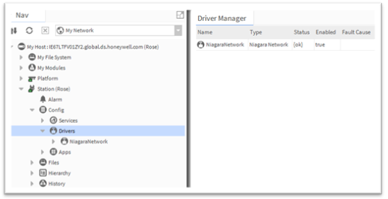

1. Double click Drivers. The Driver Manager is displayed.
2. In the bacnet palette, open **NetworkPorts**

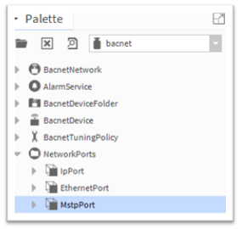

**NOTE**

Make sure to add BacnetNetwork under Drivers in the controller's station.

1. Select **MstpPort**, drag and drop the **MstpPort** to **Drivers > BacnetNetwork > Bacnet Comm >Network** in the **NAV** tree.

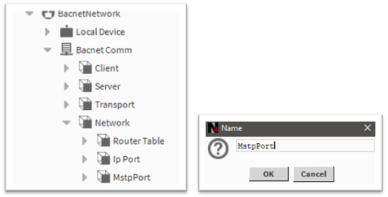

1. In the NAV tree double-click on the **MstpPort.** The MstpPort (Network Port) property sheet is displayed.
2. In the **Network Number** field, set the network number of the BACnet network segment to which the controller is being connected.
3. In the **Port Name** field, enter the Serial Port Name of the device connected to the controller port (ideally it should be COM1).  
     
   To verify the controller name, check the platSerialNPSDK property sheet.
   1. In the NAV tree navigate to **Station > Config > Service > Platform** service and double-click platSerialNPSDK to display its property sheet.

Check the Serial Port Name (COM1).

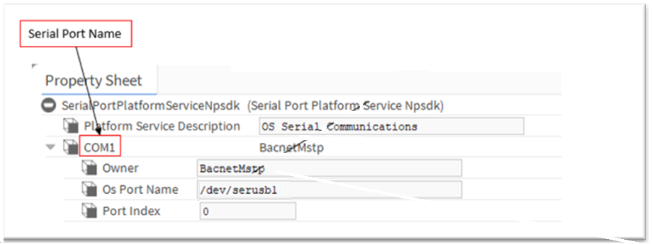

**While Testing without a USB to serial device:**

If the device is not detected or plugged in,

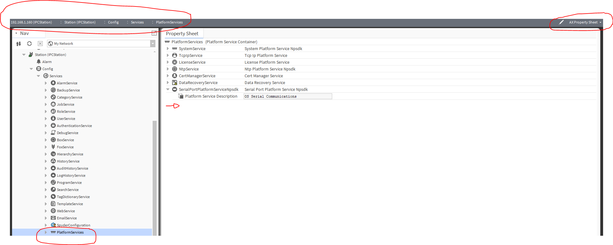

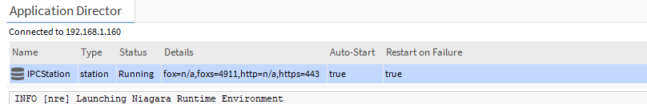

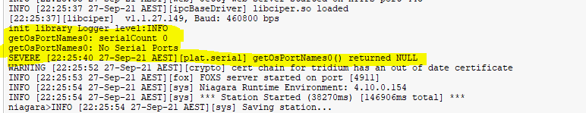

**NOTE**

* + - If there is no USB device connected to the controller, COM1 is not recognized.
    - If the COM port does not appear under npsdk service, it means CIPer Model 30 does not recognize connected 'USB to RS485' converter. Ensure the converter is connected and is using one of the supported chipsets (FTDI or Prolific).

1. In the Baud Rate field, set the baud rate that should be used for BACnet MS/TP communication. In the **Enabled** field select **true**.Configure the other parameters as required.

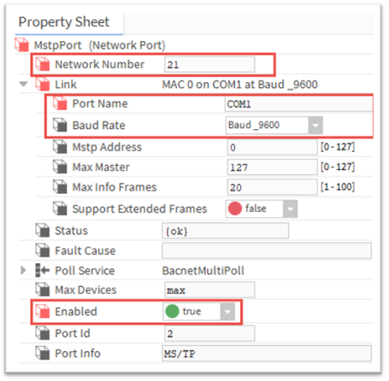

**BACnet Network Properties Description**

|  |  |
| --- | --- |
| **Property** | **Description** |
| Network Number | The BACnet network number of the network segment to which you are connecting.   * 1. If connecting to an existing BACnet installation, to use the network number for that installation.   2. For a new BACnet installation, set to the required value. |
| Port Name | The port should be the same as the name of the connected USB to RS485 convert-er. Typically, the name is COM1. |
| Baud Rate | The Baud Rate of CIPer Model 30 controllers on the BACnet MSTP bus. The baud rate of each controller is automatically set to the baud rate of the BACnet IP – MS/TP Router (this device) when the CIPer Model 30 controller is powered up and connected to the BACnet MS/TP bus.  **NOTE**: When the baud rate of the BACnet MSTP bus of a running system is changed, any CIPer Model 30 controllers connected to the bus must be disable and enabled back. |
| Mstp Address | The address of the controller on the Mstp bus. Range = 0 to 127 (default value is 0) Each BACnet controller on the MS/TP network segment must have a unique MAC address (Mstp Address). Leave the Mstp Address at 0 (the default) and verify that no other MS/TP controller has a same address |
| Max Master | Set max master value to the highest known master device on the network, with pos-sible room for expansion. |
| Max Info Frames | Controls how many messages are sent before passing the token and may be in-creased up to 50 to increase performance in some cases.  Range = 0 to 100. |
| Support Extended Frames | Enables and disables the use of larger frames, which, if supported by the device, may improve performance. |
| Status | Read only. Indicates whether the MstpPort configuration is enabled/disabled. |
| Fault Cause | Read only. Displays the details of the invalid configuration. |
| Poll Services | Allows network polling properties to be configured. |
| Max Devices | Read only. Indicates the maximum number of devices available on the network. |
| Enable | Enables/Disables the MstpPort configuration. |
| Port Id | Read only. The number of the Ethernet port being configured. |
| Port Info | Read only. Reports the type of port (Ethernet, MS/TP, etc.). |

1. Click **Save**.

**NOTE**

Every time the 'USB to RS485' connector is disconnected and reconnected, or changed to a different converter, the CIPer Model 30 controller must be power-cycled.

**Configuring ModbusAsyncNetwork**

To configure the ModbusAsynchNetwork:

1. Connect to the controller's station using Niagara Workbench.
2. In the NAV tree open the **Station > Config folder.**

ontroller's station using Niagara Workbench.

1. Double-click **Drivers.** The Driver Manager is displayed.

ontroller's station using Niagara Workbench.

1. Click **New** and select the **ModbusAsynch Network** from drop-down list.

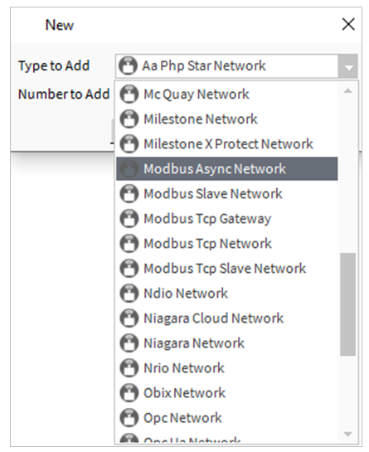

1. Click **OK.** This opens ModbusAsynchNetwork dialogue box.

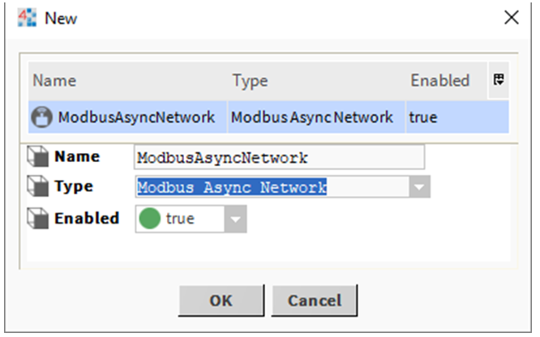

1. Click **OK.** This opens ModbusAsynchNetwork dialogue box.
2. In the NAV tree open the **Station > Config > Drivers** folder.
3. Right-click on **ModbusAsyncNetwork > Views** and select **AX property sheet**.

The propertysheet for the ModbusAsyncNetwork is displayed.

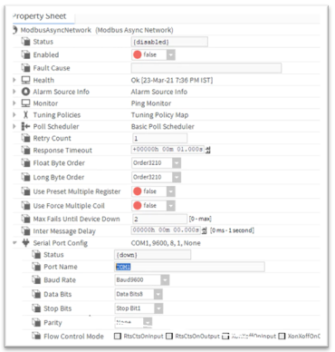

**ModbusAsyncNetwork Properties Description**

|  |  |
| --- | --- |
| **Property** | **Description** |
| Status | Read only. Indicates the condition of the ModbusAsyncNetwork configuration at the last check.  **Ok** - The component is licensed and polling successfully.  **Down** - The last check was unsuccessful, e.g. because of an incorrect property setting, or loss of network connection.  **Disabled** - The network is disabled (the Enable property is set to false).  **Fault** - There is another problem. Refer to Fault Cause for more information. |
| Port Name | The name of the USB Port. Typically, the name is COM1. |
| Baud Rate | The communication speed in bits per second. (defaults = 9600) |
| Data Bits | Specifies how many bits form a character (byte). (default = 8) |
| Stop Bits | The number of stop bits. (default = 1) |
| Parity | The parity used to confirm that the system communicated each character successfully. (default = Even) |

1. In the **Enabled** field, select **True**.
2. Expand the **Serial Port Config** property.
3. Expand the**Serial Port Config** property.
4. Expand the **Serial Port Config** property.
5. Configure the Serial port as required.
6. Click **Save.**